**Business Requirements Document (BRD)**  
**Project: SmartFin** Organizational Income and Expense Tracking System

### 1. Project Overview

Organizations often face challenges in efficiently tracking income, expenses, employee roles, attendance, and managing financial activities across various projects. This manual process can lead to financial mismanagement, reporting errors, and a lack of real-time insights into the organization’s financial health. This project aims to develop a comprehensive financial management platform that enables organizations to track income, expenses, project costs, and employee-related expenses while providing data-driven insights and role-based access control to improve decision-making and operational efficiency.

### 2. Objectives

* **Enable** organizations to manage and track income and expenses effectively.
* **Provide** a platform to monitor project-specific financials, employee expenses, and attendance.
* **Deliver** real-time financial analytics to aid in decision-making.
* **Streamline** financial reporting and compliance processes.
* **Implement** role-based access to maintain secure data handling and improve user experience based on their access privileges.

### 3. Scope

This project will include:

* **Organization Microservices**: Manage organization details, financial data, and access control for various roles.
* **Projects Microservices**: Handle project-specific income, expenses, budgets, and reporting.
* **Employee Microservices**: Manage employee details, salary, attendance tracking, and expense tracking.
* **Analytical Microservices**: Generate financial reports, charts, and insights for decision-making.
* **Role Management**: Define privileges for different users (Admin, Project Operational Managers (POMs), Finance Team, Employees) to control data access and functionalities.

### 4. Key Features and Requirements

#### 4.1 Organization Management

* **Income and Expense Tracking**: Organizations can input and track all income and expenses at a global level and per project.
* **Financial Overview Dashboard**: Display income, expenses, budget performance, and role-based summaries.

#### 4.2 Project Management

* **Project Creation**: Organizations can add projects with a defined budget, timeline, and assign employees and Project Operational Managers (POMs).
* **Budget Tracking**: Track project’s allocated budget and expenses in real-time.
* **Project-Specific Financial Reports**: Generate detailed financial reports for each project, covering budget utilization and performance.
* **Role-Based Access**: POMs have access to assign employees to projects, assess budget allocations, and manage project expenses.

#### 4.3 Employee Management

* **Employee Creation**: Add and manage employee details, including role (Admin, POM, Finance, etc.), salary, attendance, and assigned projects.
* **Employee Expense Tracking**: Track and report employee-related expenses (e.g., travel, project expenses, reimbursements).
* **Attendance Tracking**: Log and manage employee attendance and view summary reports.
* **Salary Calculation**: Automatically calculate salaries based on attendance, role, and experience.

#### 4.4 Analytics and Reporting

* **Financial Analytics**: Real-time financial data analysis, showing income vs. expenses, budget utilization, and profitability per project.
* **Custom Reports**: Generate reports for a defined period, detailing expenses, income, attendance, and project financial performance.

#### 4.5 Notifications and Alerts

* **Budget Threshold Alerts**: Notify users when project expenses approach or exceed allocated budgets.
* **Income and Expense Alerts**: Notify users for significant income or expenses added to the system.
* **Attendance Alerts**: Notify when attendance discrepancies occur or when employees have extended absences.

### 5. Functional Requirements

#### 5.1 Frontend (React & TypeScript)

* **Dashboard**: Display summaries on financials, project budgets, attendance, and role-based reports.
* **Project and Employee Forms**: User-friendly forms to add or update project and employee details, including role assignments.
* **Reports Interface**: A page where users can generate and view detailed financial and attendance reports.

#### 5.2 Backend (Node.js & TypeScript)

* **Organization Microservices**: Manage organization data, financial records, access control, and reports.
* **Project Microservices**: Handle project creation, budget tracking, project-specific financials, and role-based access.
* **Employee Microservices**: Manage employee details, role-based access, salary, attendance tracking, and expenses.
* **Analytical Microservices**: Generate financial and attendance reports and provide analytics.
* **Role Management System**: Implement user roles and permissions to provide access to specific services based on privileges.

### 6. Non-Functional Requirements

* **Performance**: The system must handle requests from large organizations, ensuring real-time analytics and minimal delay in role-based responses.
* **Security**: Secure sensitive financial and personal data, implementing encryption, and ensuring role-based access control.
* **Scalability**: The system should scale easily as projects, employees, and financial records grow.
* **Usability**: Provide an intuitive interface that adapts to user roles for streamlined navigation.

### 7. User Stories

* As an **organization manager**, I want to track the total income, expenses, and attendance of employees to maintain a balanced financial and operational overview.
* As a **project operational manager (POM)**, I want to assign employees to projects, manage project expenses, and ensure budgets stay within limits.
* As an **employee**, I want to submit my expense reports and attendance for approval to ensure timely reimbursements and accurate payroll.
* As a **financial analyst**, I want to generate custom financial and attendance reports to present insights to the leadership team.

### 8. Stakeholders

* **Organization Managers**: Responsible for overseeing finances, employee attendance, and budget utilization.
* **Project Operational Managers (POMs)**: Manage projects, budgets, and employee assignments.
* **Finance Team**: Track income, expenses, generate invoices, and process transactions.
* **Employees**: Submit expenses, track attendance, and log daily activities.
* **Financial Analysts**: Generate and review financial and attendance reports for decision-making.

### 9. Timeline

* **Phase 1 (5 days)**: Develop organization, role management, and project management features (income, expense, and project budget tracking).
* **Phase 2 (4 days)**: Implement employee management, attendance tracking, and expense tracking.
* **Phase 3 (3 days)**: Add analytics, reporting functionalities, and role-based views.
* **Phase 4 (2 days)**: Testing, deployment, and final polish (bug fixes, UI/UX enhancements).

### 10. Success Metrics

* Improved accuracy in tracking income, expenses, and attendance, reducing manual errors.
* Real-time insights for informed decision-making on finances and employee attendance.
* Role-based access control leading to streamlined workflows and data protection.

### 11. UML Metrics

**Database Diagram:** 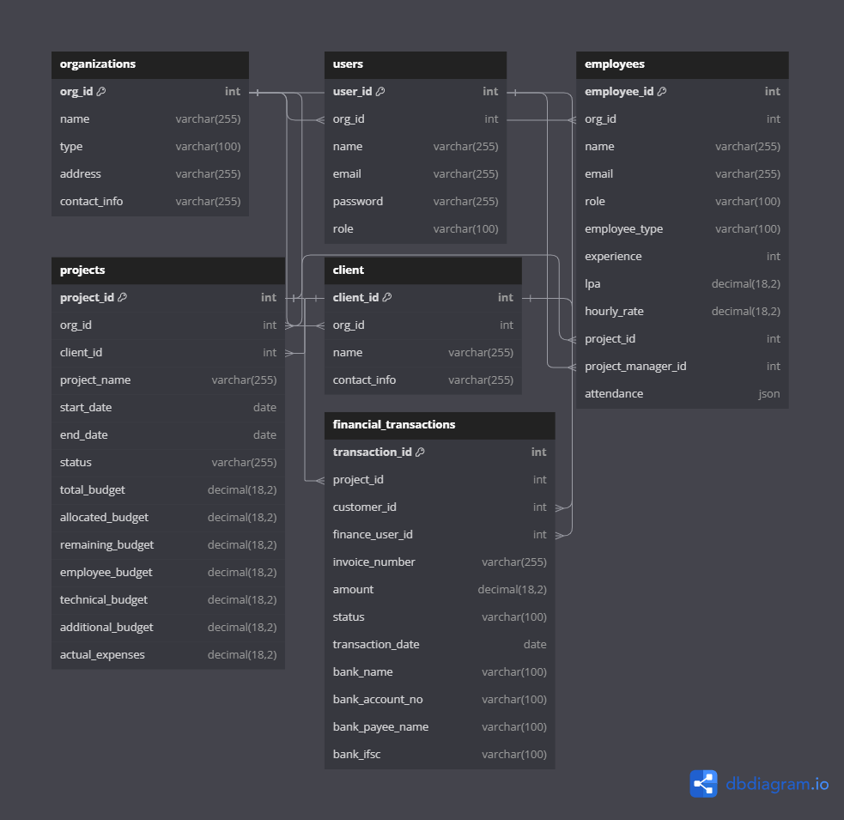

**Project Architecture:**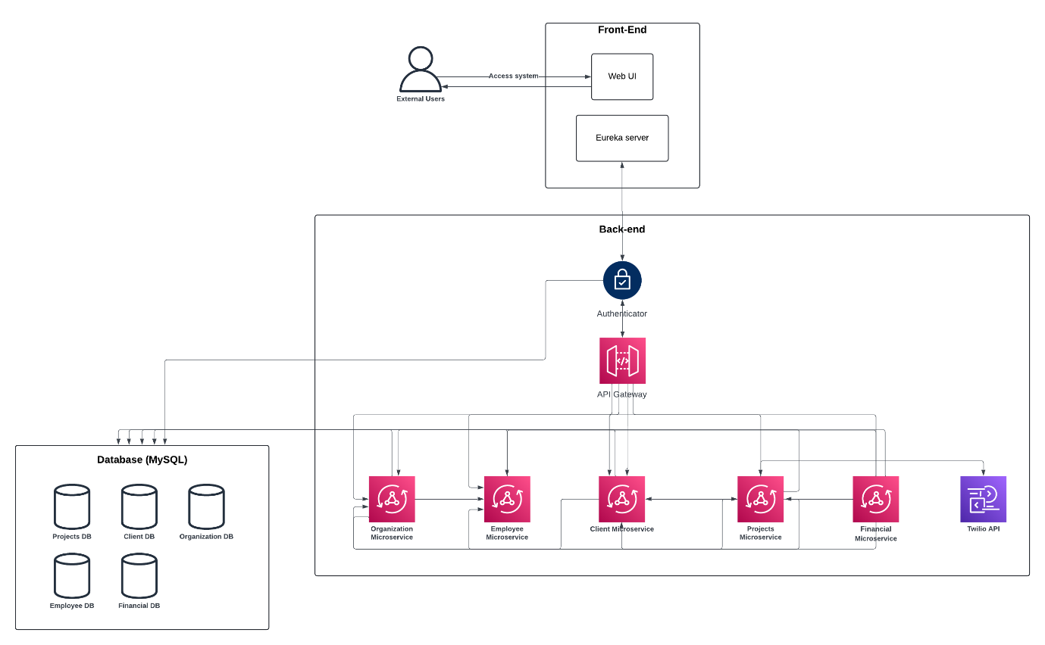

**Class Diagram:**